**Mild to Moderate evaluation**

Sample_ID: **P3HPZW (Cat)**

Link**: https://release.animalbiome.com/pet/assessment/report/appendix/892bd004-47f5-4de5-88bf-d207c66cdb3d**

Cats and dogs:

Any Two

(High Yellow Flag Megamonas OR (failed)

High Yellow Flag Sutterella OR (failed)

High Yellow Flag Collinsella OR (failed)

Low Yellow Flag Bacteroides OR (failed)

Low Yellow Flag Blautia (failed)

)

OR

OR Cats: 8-10 Yellow Flags (failed)

OR 5-8 Red Flags; (**passed**)

OR diet recommendation of increase fibre (failed)

OR diet recommendation of increase protein (failed)

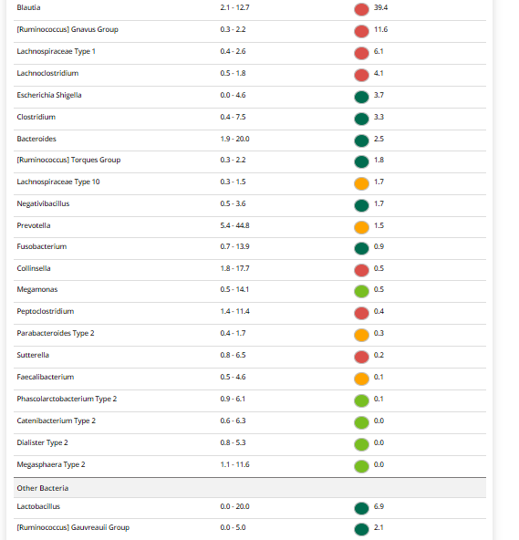

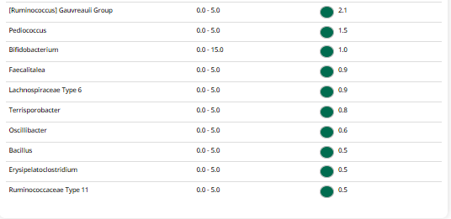

The result : **False False True False.**

Expected result : Mild to moderate

Acheived result : **passed**.

